**Project Report - CURRENCY CONVERTER**

**Introduction:**

The currency converterapplication is an currency converter applciation. This app can be used without a license and can be used by anyone. The application targets personnel. The app can be used by the students, advisors, and the administrators. The app fulfils the requirement of one person who wants to change the value of one currency to another.

**PURPOSE:**

In todays world we don’t just use services of one country. Thus we should be able to convert currencies easily if we want to deal in forregin currencies. This app helps each that individual who wants to convert the values from one to another.

**PROJECT SUPPORT:**

To use this app, one needs to install the apk file in the android phone.

So far the app is just compatible in the android studio where we can see the functionality of the app in the android emulator.

**APP FUNCTIONALITY:**

App does various functions but limited to only 2 3 features so far. Such as

Converting currencies

Reseting the values

In this app one user can convert the values from one currency to another by just pressing the convert buttons.

App takes the value from one edit text field and after pressing the convert button it converts and shows the values on the other text fields, the respective ones.

**SCREENSHOTS:**

Here are some screenshots of the functionality of app:

CASE 1: Every value is being reset to 0 by pressing the reset button.

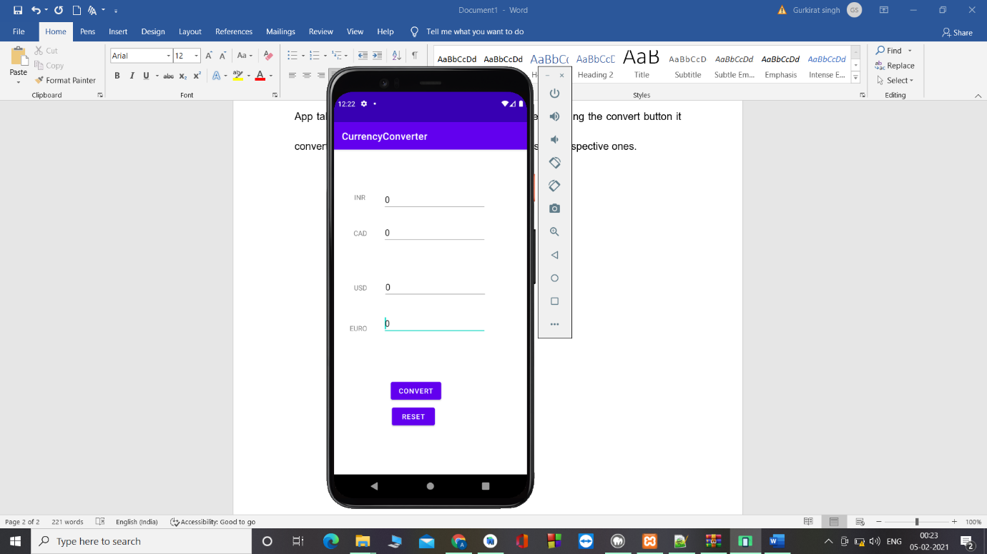

CASE 2: changing value of inr and after pressing the convert, every other field changes to respective value.

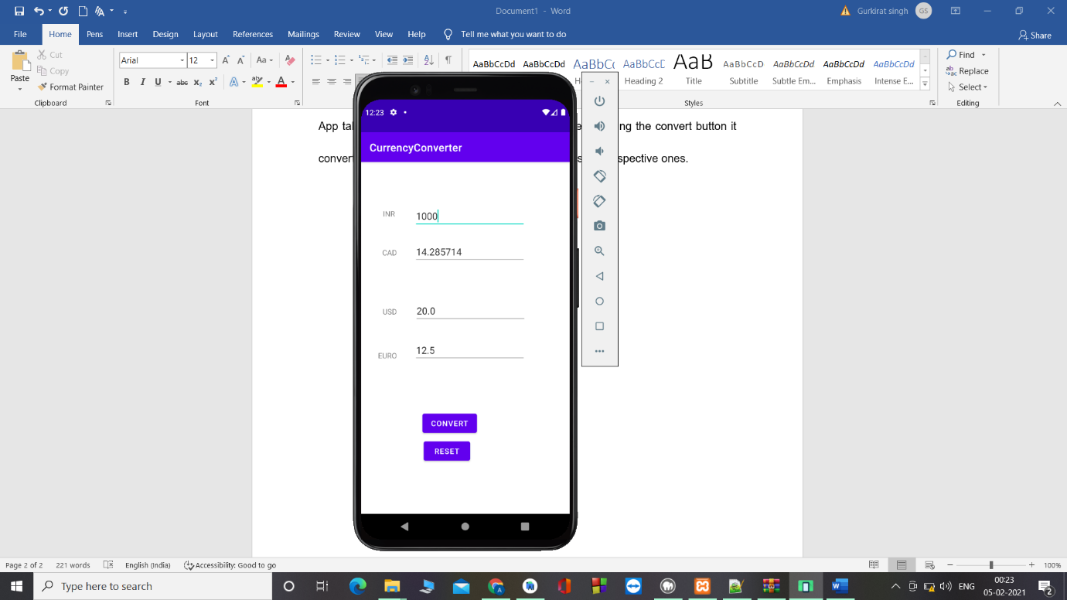

Now here we can see when value of INR is 1000 and afrte pressing the convert value changes to:

CAD – 14.2

USD – 20

EURO – 12.5

Now if we want to change the values of other currencies we have to change the value to 0 by pressing the reset button.

CASE 3: now we will try to change the value of cad to other currencies by first resetiong 0 and then pressing convert:

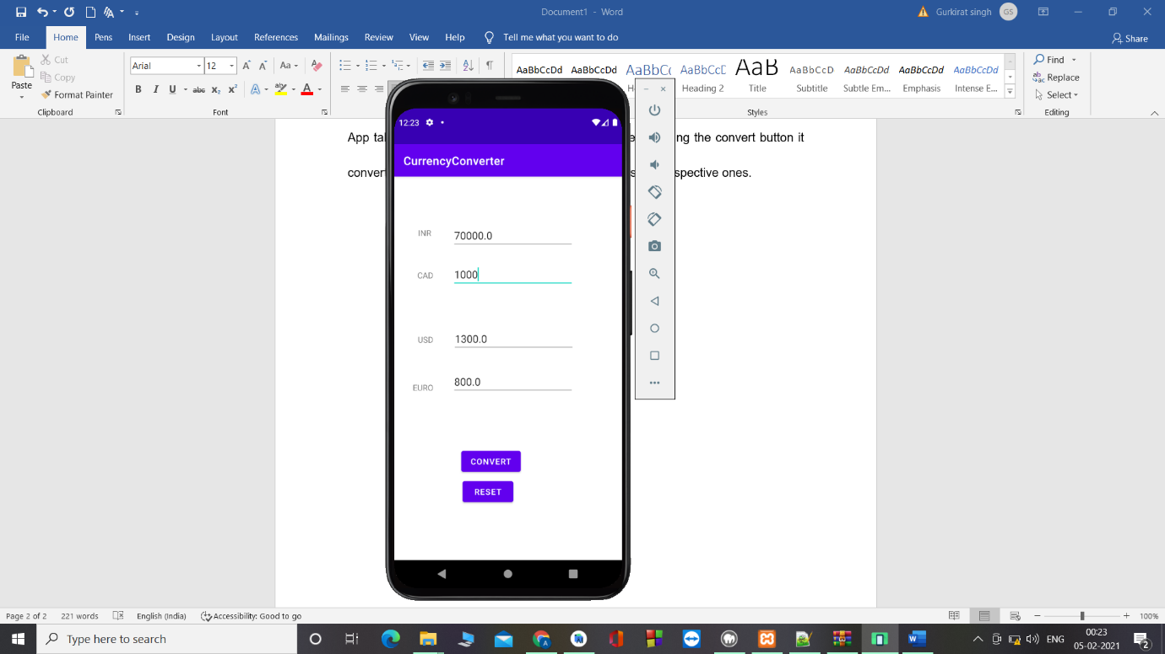

Here 1000 cad changes to

70000 INR

1200 USD

800 EURO

This is the basic working of the app

This is not a final app while still in progress, where other currencies will be added with which u can convert it to more values.

More values will be added later on